Participant Guide
EVENT
- Black Feather & Centennial Districts’ Klondike

DATES
- Friday, January 29, through Sunday, January 31, 2021

LOCATION
- Camp Cris Dobbins @ Peaceful Valley Scout Ranch
  - 22779 N Elbert Road
  - Elbert, CO 80106
https://www.denverboyscouts.org/wp-content/uploads/2019/10/Dobbins-Map-2.19-Update.pdf

COST
- $15/Person (Early Registration – Prior to January 15)
- $20/Person (Late Registration – January 16 – 23)

CONTACT
- David Short (Klondike Chair)
  - (303) 881-7790
  - DMShort80124@gmail.com

EXECUTIVE SUMMARY
This premier District winter camping event is open for all Troops and Crews to test their Scout skills and show their Scout spirit.

REGISTRATION
- BLACK FEATHER DISTRICT UNITS
  - https://www.denverboyscouts.org/districts/black-feather/
- CENTENNIAL DISTRICT UNITS
  - https://www.denverboyscouts.org/districts/centennial/
Please note that all registration fees are NON-REFUNDABLE.

DIRECTIONS
From Franktown follow CO-86 East to Kiowa. Turn South on North Elbert Road. Turn East at camp entrance. Ranch HQ first building on your right.
http://www.denverboyscouts.org/wp-content/uploads/2019/mappv.pdf

ROAD/WEATHER CONDITIONS
Please check road/weather conditions starting Friday afternoon.

CHECK-IN
Prior to your arrival your UNIT will be assigned a campsite location based on the number of registered Scouts/Scouters registered attending. Once your unit is set-up, please have two youth and one adult check-in at the Klondike HQ (Ranch HQ). Bring with you the following items:
- Copy of your Unit’s Final Roster (attachments).
- Corresponding BSA Medical Forms.
  - Parts A&B completed for ALL Scouts, Scouters and any parents attending.
    - Please note that we will collect them and return them when your unit checks-out!
- Payment for any balance due for additional registrations (late registrations are $20/person).
  - Checks or EXACT Cash. Credit Cards WILL NOT be accepted.
- Unit # & Respective Patrol Name(s) for the UNIT (attachment).
  - NOTE: ALL events will be based on Patrols consisting of eight (8) Scouts.

CHECK-IN (Continued)
Due to our volume of traffic, unloading and parking can be a slow process. Please be patient and follow the instructions of our traffic control personnel.
All vehicle parking will be at the parking lot. Trailers may be dropped at the respective campsite; however, please ensure that . This allows for one-way traffic.
Parking for day visitors will be on the main campground road. NOT in the campsite loops. This parking lot is located on the right side as you enter.
Parking is limited. Therefore, units are encouraged to either carpool or due to Covid-19 restrictions have Scouts and their equipment dropped off and then picked up by their families.

OVENIGHT & DAY USE CAMP SET-UP
Participants should be sleeping in tents. No travel trailers, RVs or buses are permitted at this event.
- Please note that if extending circumstances exist, you must seek and receive prior written approval before the end of the registration period for the Klondoree (Saturday, January 23, 2021).
  - DMShort80124@gmail.com

GUIDE TO SAFE SCOUTING

The Klondoree will follow the Guide to Safe Scouting. You may obtain a copy via the following link:
https://filestore.scouting.org/filestore/pdg/34416.pdf

SCOUT ESSENTIALS

All Scouts/Scouters should always bring their Scout Essentials with them.
https://scoutingmagazine.org/2013/02/the-10-essentials/

MEDICAL ASSISTANCE
Every unit should be able to provide basic first aid to all their participants. However, if additional medical services are needed you are to contact the Klondoree HQ.
For Emergencies and/or First Aid Emergencies and First Aid Phone Number is 911.
- Cell phone coverage at Peaceful Valley Scout Ranch is very limited and unreliable.
  - Some coverage can be obtained in parts of the Cris Dobbins Campground dependent on provider.
- Internet coverage is not available in the campgrounds.

EMERGENCIES
Local Emergency Agency is the Elbert County Sheriff’s Office.

COVID-19
All units should follow the BSA Restart Scouting Check-list.
https://filestore.scouting.org/filestore/HealthSafety/pdf/680-693.pdf

- Event Protocols:
  - All Scouts/Scouters should wear face masks when traveling to and from event stations, bathrooms, HQ, Medical Center, Dining Hall and/or common areas.
  - All Scouts/Scouters should honor social distancing, e.g., 6’ + between themselves and others outside of their unit when traveling to and from or waiting at event stations, bathrooms, HQ and/or common areas.
  - Please cover coughs.
  - Please wash hands frequently.
  - Disinfected Wipes (Unit Provided)
    - Each patrol/crew should wipe down all common items with disinfected wipes they provide after the completion of the event.
- Each event will have the following:
  - Hand Sanitizer (Event Provided)
    - Please have each Scout/Scouter use the hand sanitizer after each event if their hands are not gloved.

FIRES
- No wood will be available at the campsites.
  - Wood gathering within the campgrounds is NOT permitted.
    - Therefore, your UNIT must bring all the wood and kindling needed for the campout with you.
- Wood fires are only permitted in the established fire grates or containers that are off the ground.
  - A final ruling on open fires will be made the weekend of the event. We are subject to notification from the sheriff’s office and Camp authorities.
  - ALL FIRES MUST BE ATTENDED BY THEIR UNIT!
    - No fires should be left burning without someone caring for them.
    - All fire ashes must be removed by your Troop and taken home; do not leave ashes behind in the fire rings/grates.
      - Bring suitable empty containers for this purpose.
        - Practice leave no trace!
- Absolutely NO OPEN FLAMES IN TENTS.
- Absolutely NO COOKING IN TENTS.

Water
Running water should be available at select times and locations during the Klondike. However, your unit is encouraged to bring all your own water needed for the entire weekend!
Dehydration can occur just as fast in cold weather as in warm weather. Even faster at altitude. Therefore, be sure to bring extra water.
Each Scout needs to have a filled water bottle with them on Saturday. Be careful that those water bottles/bladders don’t freeze in cold weather. Leaders too need to stay hydrated!

FOOD
Each unit will be responsible for their own meals. If any Webelos Scouts and their parents are joining a Troop on Saturday, they should plan to eat meals with their sponsoring Unit. As a result, Troops should account for any visitors in their meal planning.
- Please note that every meal should include a “hot” element. For example, lunch can include “soup” to help maintain Scouts/Scouters’ body temperatures in cold weather.
The use of stoves rather than fires for cooking is strongly recommended to help expedite the cooking process.

TRASH
The trash receptacles for the campsites are not to be used. There will be no trash receptacles on site. UNITS are responsible for removing and taking home ALL trash, including food, wrappers, and fire ashes.
- Practice Leave No Trace.

TOLIETS
Please use toilets and camp restrooms. Wash hands after use.

CAMP RULES
- Mechanized snow removal equipment, included snowplows and snow blowers, are not permitted.
- Driving onto unplowed areas, including unplowed site pullouts, is not permitted.
- Respect wildlife.
  - Do NOT feed or harass any animals.

LOST & FOUND
- Lost and Found will be located at the Klondike Headquarters (Ranch HQ building).
  - Consider labeling all items with a last name and Troop/Crew number with a permanent marker.

KLONDOREE PERSONAL EQUIPMENT RECOMMENDATIONS
Wear
- Class A Uniform
  - Covid-19 Face covering
  - Knit or Wool Hat OR Balaclava
  - Winter Jacket (Water & Wind Resistant recommended)
  - Scout Shirt
  - Snow Pants (Water & Wind Resistant recommended)
  - Scout Belt
  - Scout Socks
  - Sock Liners
  - Gloves OR Mittens (Water & Wind Resistant recommended)
  - Snow Boots, e.g., Sorrels, etc.
  - Gaiters (Optional)
Bring
- Duffel Bag OR 50 L + Pack
  - Fleece Sweater OR Jacket
    - This past year’s weather: HIGH 40° F and LOW 9° F Elevation: 6,715’
  - Sleep Clothes in stuff sack (plastic zip lock bag will work too)
    - Long-Johns (Shirt & Bottom) AND Wool Socks OR Down Booties
  - Extra Clothes in stuff sack (plastic zip lock bag will work too)
    - Long-Sleeve Shirt (1)
    - Scout Pants (1)
    - Socks (1 extra pair)
    - Sock Liners (1 extra pair)
    - Synthetic Underwear & T-Shirt (1 extra pair)
    - Gloves OR Mittens (2-Pairs total)
  - Mess Kit (Plastic works well!)
    - Cup
    - Bowl
    - Fork & Spoon OR Spork
  - Hygiene Kit
    - Toothbrush & Toothpaste
    - Comb
    - Small towel
  - 0° F or less Rated Sleeping Bag with Stuff Sack
    - If your sleeping bag is NOT rated to zero degrees you may use two sleeping bags (stuff one inside the other) OR add a fleece liner (lowers bag temperate rating by approximately 10 - 20° F) to your sleeping bag’s rated temperature, e.g., 20° F → 10 - 0° F
  - Sleeping Pad (Closed Cell or “high” R value)
- Day Pack
  - Scouts Essentials
    - Headlamp OR Flashlight
    - Compass & Map (Will be provided at shakedown)
    - Water (2-Quarts (32 OZ))
    - Knife (& Totem Chip Card)
    - Rain Gear AND Extra Clothes
      - Waterproof Jacket & Waterproof Pants
        - Ponchos are not recommended
    - Small Personal First Aid Kit (Recommended)
      - Non-Latex Gloves (1 pair)
      - Alcohol Wipe
      - Bandages (Assorted sizes 2 – 3 each)
      - Triple Antibiotic, e.g., Neosporin
      - Moleskin (Blister Prevention/Treatment)
    - Sun Protection
      - Wide brim Hat
      - Sunscreen & Lip Balm
      - Sunglasses
    - Waterproof Matches OR Fire Starter, e.g., Flint & Steel
    - Trail Food, e.g., energy bar, gorp, etc.
- Other Recommended
  - Scout Handbook
  - Watch
  - Pencil & Paper
  - Camp Chair
  - Bandana (Cotton is OKAY)
  - Hand AND/OR Foot warmers (OPTIONAL)
  - Scarf AND/OR Buff (OPTIONAL)

Scouts should dress in Layers. Synthetic and tight clothing to be worn next to the skin, and water/wind proof on their outer layer. One to two warms layers of clothing in between. Wool and fleece clothing provide a good warmth to weight ratio. Additionally, do not bring any COTTON clothing! For example, NO cotton jeans or sweatshirts! Cotton will not maintain any thermal value once wet and they will not dry in winter conditions!
Finally, it is NOT recommended that you bring any electronics, e.g., smart phones, games, chargers, etc. Electrical outlets are not available, as well as, winter camping conditions (cold) is not ideal.

SCHEDULE

Friday, January 29
2:00 – 9:00 PM | Arrival & Camp Set-Up
4:00 PM | Registration Opens at Klondike HQ (Ranch HQ Building)
9:00 PM | Registration Closes at Klondike HQ (Ranch HQ Building)
10:00 PM | Taps (Lights Out & Quiet Time)

Saturday, January 30
7:00 – 8:30 AM | Reveille & Breakfast
7:30 – 8:30 AM | Registration Opens at Klondike HQ (Ranch HQ Building)
8:45 AM | Opening Flags
9:00 – 9:20 AM | Event Session #1
9:20 – 9:40 AM | Event Session #2
9:40 – 10:00 AM | Event Session #3
10:00 – 10:20 AM | Event Session #4
10:20 – 10:40 AM | Event Session #5
10:40 – 11:00 AM | Event Session #6
11:00 – 11:20 AM | Event Session #7
11:20 AM – 1:00 PM | Lunch
1:00 – 1:20 PM | Event Session #8
1:20 – 1:40 PM | Event Session #9
1:40 – 2:00 PM | Event Session #10
2:00 – 2:20 PM | Event Session #11
2:20 – 2:40 PM | Event Session #12
2:40 – 3:00 PM | Event Session #13
3:00 – 3:20 PM | Event Session #14
3:20 – 4:45PM | Iditarod & Free Time
4:45 – 5:00 PM | Closing Flags
5:00 – 7:00 PM | Dinner
7:30 – 8:30 PM | Award’s Ceremony & Cracker Barrel (Dining Hall)
10:00 PM | Taps (Lights Out & Quiet Time)

Sunday, January 31
7:00 AM | Reveille, Breakfast & Break Camp
8:30 – 9:00 AM | Scout’s Own Service (McKenzie Range)
9:00 – 10:30 AM | Check-Out at Klondoree HQ

EVENT NAME | BRIEF EVENT DESCRIPTION
#1  Boling Over! | Patrol will build and light a fire in an attempt to boil water in less than 5-minutes without using accelerants. (TIMED EVENT)
#8  Snap, Crackle, Pop! | Patrol will build and light a fire to “pop” a popcorn kernel within the 5-minute time limit without using accelerants. (TIMED EVENT)
#2  The “A” Team! | Patrol will correctly lash three staves to create an a-frame in less than 5-minutes. ((TIMED EVENT)
#9  All Tied Up in Knots! | Scouts draw one of the six knots required for rank advancement. Run to a spot. Correctly tie the knot and then run back to tag another teammate. Repeat until eight (8) knots are tied. (TIMED EVENT)
#3  Be Prepared! | The Patrol/Crew is inspected at this station. All Scouts needs to produce each of their ten essentials, as well as, the patrol must produce their required support items. (POINT EVENT)
#10  Iced Up! | Patrol attaches their rope they are carrying to a rope provided & then throws it to a victim 25' feet away, who ties a bowline around themself & then is pulled ashore by the rest of the Patrol. (TIMED EVENT)
#4  Yeti Throw! | Patrol creates snowballs & throws them into a "Yeti's" mouth rotating everyone for 5-minutes. Maximum time is 5 Minutes. (POINT EVENT)
#11  Owl Pellet Drop! | Your basic Corn Hole game. Each patrol member rotates through to complete as many scoring tosses within a fixed time frame. (POINT EVENT)
#5  For the Birds! | This is a basic bird identification. Each patrol will be shown a photo and the scientific name to identify as many as possible in 5-Minutes. (POINT EVENT)
#12  Leaf Me Alone! | This is a basic tree identification. Each patrol will be given photos (tree & leaves), descriptors and the scientific name to identify as many as possible in 5-Minutes. (POINT EVENT)
#6  Mush! | Your basic sled dash for approximately 40-yards. (TIMED EVENT)
#13  Pulka Push! | Your basic build a sled, i.e., pioneering event, with the objective to move an object from one point to another. (TIMED EVENT)
#7  Tandem Trekkers! | Two (2) different Scouts per round put on snowshoes together and shuttle around a post and back until eight Scouts from the patrol have competed in the fast time possible. (TIMED EVENT)
#14  Snowshoe Relay! | Eight (8) Scouts put on snowshoes and a pack one at a time, and shuttle in a relay race around a pole and back to tag the next Scout in the fastest time. (TIMED EVENT)
#15  Iditarod! | Your basic overland sled race. (TIMED EVENT)

PATROL/CREW EQUIPMENT NEEDED for EVENTS
The Scout Motto is BE PREPARED. As a result, Patrols/Crews are expected to have with them the following equipment for the start of their respective event(s).
- Sled
- 10’+ Rope
- Kindling (Needed for Two Fire Building Events)
- Pencil for recording your scores
- Hand wipes (cleaning commonly used items after the event)

SCOUT EQUIPMENT
- Every Scout should always carry their Scout Essentials (10).

EVENT SCORING
- Patrols/Crews will be ranked either based on elapsed time to complete the task or on points achieved.
  - Fastest TIME → slowest time.
  - Most POINTS → least points.
- The Top 3 Patrols/Crews at each event will be recognized with a ribbon.
- The Top 3 Patrols/Crews across all competitions will also be recognized with a ribbon for their unit.

EVENT JUDGING
- Adult Scouters will have to judge each event for their own unit due to COVID-19 restrictions. The expectation is that each Troop/Crew will be TRUSTWORTHY and follow the written rules & guidelines for scoring each event. PLEASE no exceptions.
- All Scouters should have a “stopwatch” for timed events.
- Please record the time or score on the scoresheet as instructed.
  - The Patrol/Crew leader should provide a “writing instrument” to record the score after each event!

AWARDS CEREMONY
- Please join us at the Dining Hall at 7:30 PM Saturday evening for a socially distant Awards Ceremony and Cracker Barrel!

PATCH

All registered participants will receive one (1) Klondoree patch to commemorate the event.

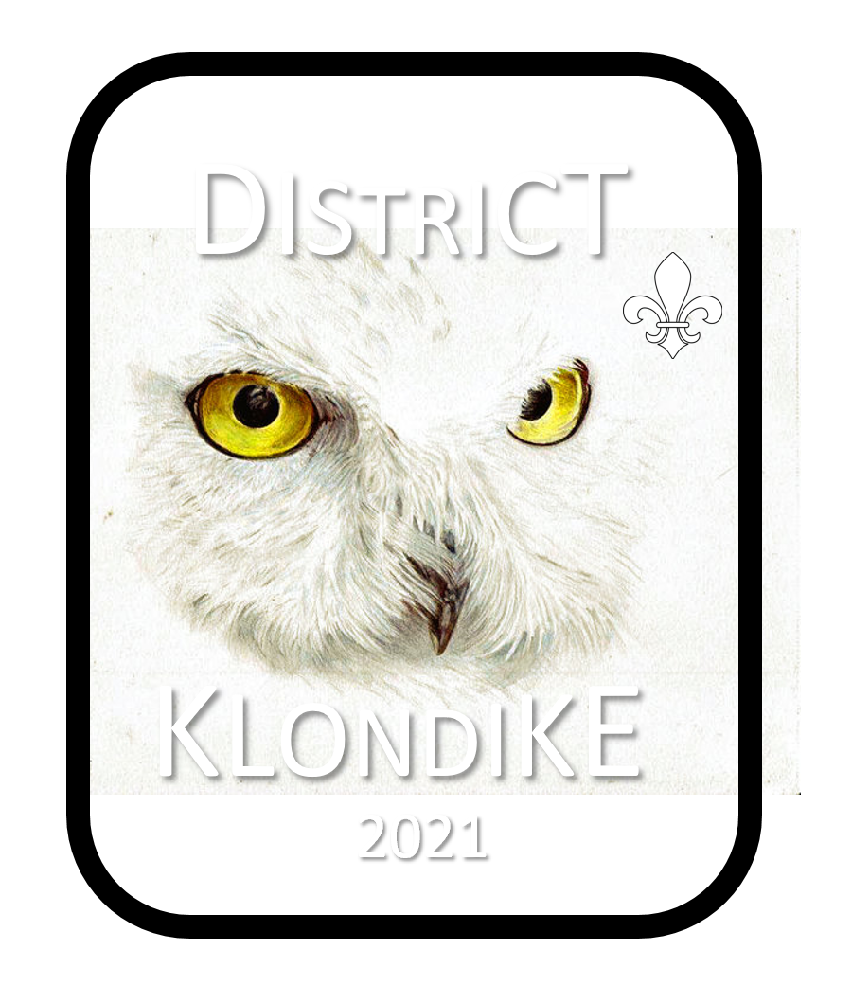

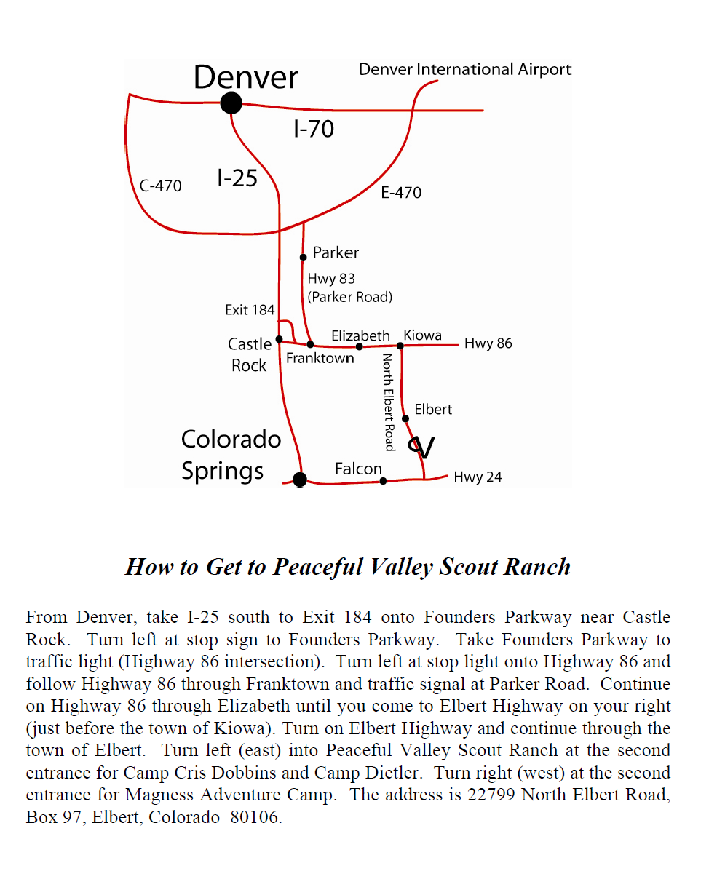

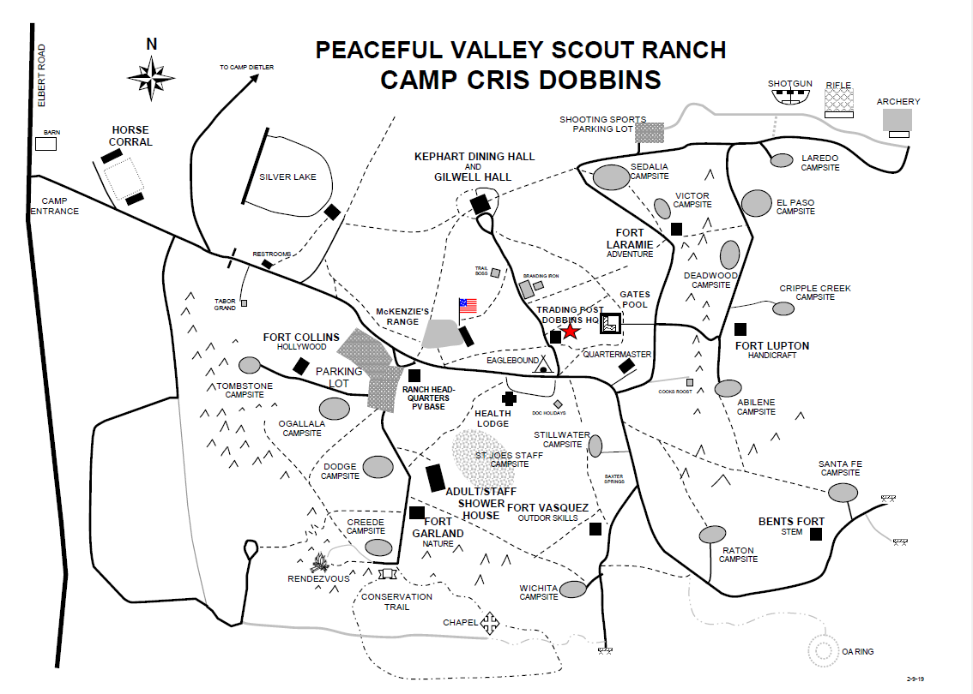
REGISTRATION FORM
TROOP/CREW #________________ DISTRICT ________________________________
(circle above)
PATROL NICKNAME: __________________________________________ # SCOUTS _____
YOUTH NAME(S) | AGE(S)

PATROL NICKNAME: __________________________________________ # SCOUTS _____
YOUTH NAME(S) | AGE(S)

(reproduce form as necessary – bring completed form to Check-In (Klondike HQ)

REGISTRATION FORM
TROOP/CREW #________________ DISTRICT ________________________________
(circle above)
ADULT NAME(S) | POSITION(S)

(reproduce form as necessary – bring completed form to Check-In (Klondike HQ)
UNIT # __________ PATROL NAME ______________________________________
(Circle One: TROOP CREW)
AM SCORE SHEET

- BOILING OVER! TIME ____________________ (MINUTES:SECONDS)

- THE “A” TEAM! TIME ____________________ (MINUTES:SECONDS)

  - Only SQUARE lashing used Y N (circle)

- BE PREPARED! #ITEMS _______________ #SCOUTS _______________

- YETI THROW! POINTS _______________

- FOR THE BIRDS!
- _________________________ 16) _________________________
- _________________________ 17) _________________________
- _________________________ 18) _________________________
- _________________________ 19) _________________________
- _________________________ 20) _________________________
- _________________________ 21) _________________________
- _________________________ 22) _________________________
- _________________________ 23) _________________________
- _________________________ 24) _________________________
- _________________________ 25) _________________________
- _________________________ 26) _________________________
- _________________________ 27) _________________________
- _________________________ 28) _________________________
- _________________________ 29) _________________________
- _________________________ 30) _________________________

- MUSH! TIME ____________________ (MINUTES:SECONDS)

- TANDUM TREKKERS! TIME ____________________ (MINUTES:SECONDS)
(reproduce form as necessary – bring completed form to Klondike HQ after events)
UNIT # __________ PATROL NAME ______________________________________
(Circle One: TROOP CREW)
PM SCORE SHEET

- SNAP, CRACKLE, POP! TIME ____________________ (MINUTES:SECONDS)

- ALL TIED UP IN KNOTS! TIME ____________________ (MINUTES:SECONDS)

- ICED UP! TIME ____________________ (MINUTES:SECONDS)

  - Bowline tied correctly Y N (circle)
  - Sheet Bend tied correctly Y N (circle)

- OWL PELLET DROP! POINTS _______________

- UP IN TREES!
- _________________________ 11) _________________________
- _________________________ 12) _________________________
- _________________________ 13) _________________________
- _________________________ 14) _________________________
- _________________________ 15) _________________________
- _________________________ 16) _________________________
- _________________________ 17) _________________________
- _________________________ 18) _________________________
- _________________________ 19) _________________________
- _________________________ 20) _________________________

- PULKA PUSH! TIME ____________________ (MINUTES:SECONDS)

- SNOWSHOE RELAY! TIME ____________________ (MINUTES:SECONDS)

- IDITAROD! TIME ____________________ (MINUTES:SECONDS)

(reproduce form as necessary – bring completed form to Klondike HQ after events)

