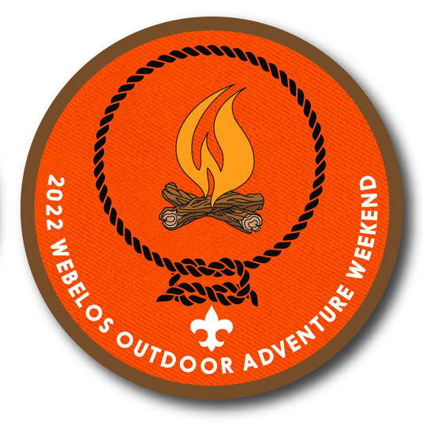

Leaders Guide
EVENT
- 2022 Webelos Outdoor Adventure Weekend

TIMES & DATES
- 8:00 AM, Saturday, October 8 – 11:00 AM Sunday, October 9, 2022

LOCATION
- McNeil Scout Ranch @ Peaceful Valley
  - 22798 N Elbert Road
  - Elbert, CO 80106
- Magnus Adventure Camp

COST
- $75.00/Webelos & Parent/Guardian (ONE Webelos & ONE Parent/Guardian)
- $112.50/TWO Webelos & ONE Parent/Guardian (3 People)
  - A parent/guardian must accompany each Webelos.
  - If there the Scout is female, they must be accompanied by a female adult.

CONTACT
- David Short (Event Chair & Short-Term Camp Administrator)
  - (303) 881-7790
  - DMShort80124@gmail.com

EXECUTIVE SUMMARY
The 2022 Webelos Outdoor Adventure Weekend is Black Feather & Centennial’s premier fall camping event for Webelos & Arrow of Light.
Daytime Troop-sponsored events will feature some advancement opportunities. Saturday evening will include a Campfire and cracker barrel, and Webelos & their parent/guardian can spend the night under the stars.

DIRECTIONS
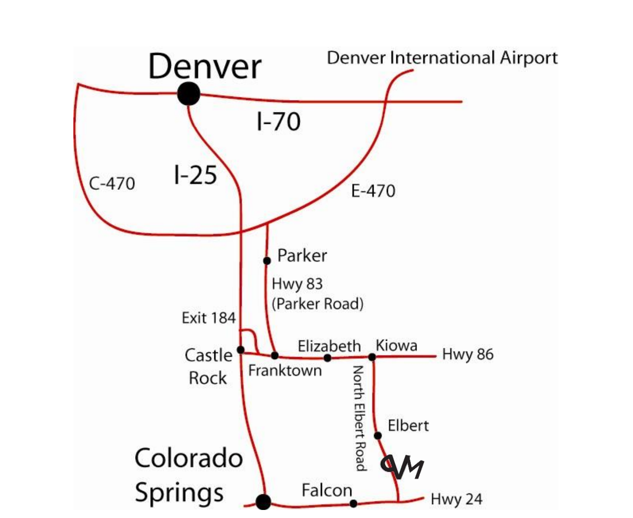

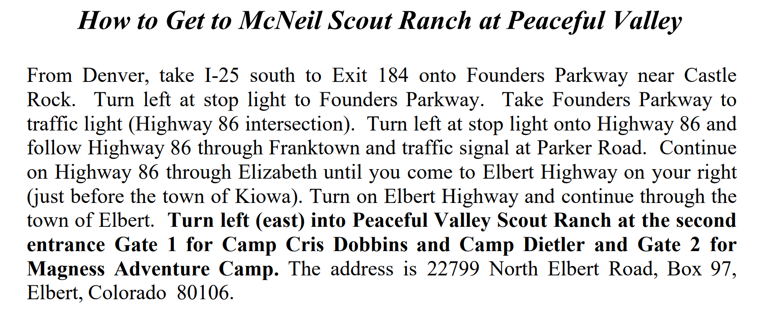
REGISTRATION
All Webelos & Parent/Guardians register via the DAC website & monthly calendar.
- https://denverboyscouts.doubleknot.com/event/calendar/1704?orgselect=-1

Registration will CLOSE on Monday, October 3, 2022, at 11:59 PM. No walk-ins will be accepted. Please note that all registration fees are NON-REFUNDABLE.
NOTE: This event is limited to the first 200 Webelos & Parents/Guardians!

CHECK-IN
Please check-in by reporting to the Webelos Weekend event CHECK-IN area prior to dropping equipment OR unloading vehicles. This is located at the upper parking lot.
Bring with you the following items:
- Corresponding BSA Medical Forms.
  - Parts A&B completed for ALL Scouts, Scouters and any parents attending.
  - All registered Adults MUST have a copy of their YPT (Youth Protection Certificate) attached to their medical forms.
  - Medical Forms may be found through the following link:
    - https://www.scouting.org/health-and-safety/ahmr/
      - All Scouting Events (<72 hours)
Parking is limited. Therefore, units are encouraged to carpool. Too, you will have to carry your gear from the parking lot to your camping area. Therefore, plan accordingly.

OVERNIGHT & DAY USE CAMP SET-UP
Participants should be sleeping in tents. No travel trailers, RVs or buses are permitted at this event.
- Please note that if extending circumstances exist, you must seek and receive prior written approval by emailing the below contact by Friday, September 30, 2022.
  - DMShort80124@gmail.com

GUIDE TO SAFE SCOUTING

Webelos Weekend Participants will follow the Guide to Safe Scouting. You may obtain a copy via the following link:
https://filestore.scouting.org/filestore/pdg/34416.pdf

SCOUT ESSENTIALS

All Webelos, Parents, Scouts & Scouters should always have in their possession their Scout Essentials. You may obtain as copy via the following link:
https://scoutingmagazine.org/2013/02/the-10-essentials/

MEDICAL ASSISTANCE
Basic first aid to all participants and staff can be provided at the Weekend HQ.
For Emergencies and/or First Aid Emergencies and First Aid Phone Number is 911.
- Cell phone coverage at McNeil Scout Ranch can be limited and unreliable.
  - Coverage is contingent based on your location and your provider.
- Internet coverage is not available.

EMERGENCIES
Local Emergency Agency is the Elbert County Sheriff’s Office.

FIRES
NO OPEN FIRES are permitted.

Water
Running water will NOT be available at the Webelos Weekend Camporee. However, we will have some water stations set up. ALL Webelos and Parents are encouraged to bring all your own water needed for the entire weekend!
Dehydration can occur just as fast in cold weather as in warm weather. Each Scout needs to have a filled water bottle with them on Saturday. Parents/Guardians too need to stay hydrated!

LEAVE NO TRACE
Our expectation is that everyone will practice the Leave No Trace principals.
- Plan ahead & prepare.
- Travel & camp on durable surfaces.
- Dispose of waste properly.
- Leave what you find.
- Minimize campfire impact.
- Respect Wildlife.
- Be considerate of others.

FOOD
Lunch, dinner, cracker barrel & breakfast will be provided. If you plan to bring your own snacks or food, please plan to keep those items in a secure container in your car as you might attract wildlife.

TRASH
The trash receptacles for the campsites are not to be used. There will be no trash receptacles on site. INDIVIDUALS are responsible for removing and taking home ALL trash, including food, wrappers, etc. Basically, pack it in and pack it out!

TOLIETS
We will be providing porta-potties for this event. Wash hands after use.

CAMP RULES
- Follow the Scout Oath & Law!
- Practice Leave No Trace.
- Follow Youth Protection Training (YPT) guidelines.
- Park only in designated parking areas.
- Webelos are not to be at the lake unless with adult supervision.
- No electronic games, or music players allowed at this event.
- No fires, alcoholic beverages, fireworks, or firearms allowed at this event.
- Rocks, sticks and pinecones are to be left in place on the ground.
- The BUDDY SYSTEM should be used all the time.

LOST & FOUND
- Lost and found will be located at the Weekend Headquarters (HQ).
  - Consider labeling all items with a last name and Pack number with a permanent marker.

Wear
- Class A Uniform
  - Wide Brim Hat
  - Insulated Jacket (Water & Wind Resistant recommended)
  - Scout Shirt
  - Scout Pants
  - Scout Belt
  - Scout Socks
  - Hiking Boots or Tennis Shoes
    - Open toe shoes are NOT permitted in Camp
  - NOTE: Feel free to leave your neckerchief and slide at home as they tend to get lost on campouts!
Bring
- Duffel Bag OR Pack (your gear will be carried from parking lot to campsite)
  - Fleece Sweater OR Jacket
    - The historical average weather forecast for our weekend:
    - HIGH 69° F and LOW 39° F
  - Sleep Clothes in stuff sack (plastic zip lock bag will work too)
    - Long-Johns (Shirt & Bottom) AND Wool Socks
  - Extra Clothes in stuff sack (plastic zip lock bag will work too)
    - Knit Cap (1)
    - Socks (1 extra pair)
    - Sock Liners (1 extra pair)
    - Synthetic Underwear & T-Shirt (1 extra pair)
    - Gloves OR Mittens
  - Hygiene Kit
    - Toothbrush & Toothpaste
    - Comb
    - Small towel
  - 20° F or less Rated Sleeping Bag with Stuff Sack
    - If your sleeping bag is NOT rated to 20 degrees you may use two sleeping bags (stuff one inside the other) OR add a fleece liner (lowers bag temperate rating by approximately 10 - 20° F) to your sleeping bag’s rated temperature, e.g., 30° F → 20 - 10° F
  - Sleeping Pad
  - Tent, stakes, poles, etc.
    - Webelos & parent/guardian will share a tent together.
- Day Pack
  - Scouts Essentials
    - Headlamp OR Flashlight
    - Compass & Map
    - Water (2-Quarts (32 OZ))
    - Knife (& Totem Chip Card)
    - Rain Gear AND Extra Clothes
      - Waterproof Jacket & Waterproof Pants
        - Ponchos are not recommended
    - Small Personal First Aid Kit (Recommended)
      - Non-Latex Gloves (1 pair)
      - Alcohol Wipe
      - Bandages (Assorted sizes 2 – 3 each)
      - Triple Antibiotic, e.g., Neosporin
      - Moleskin (Blister Prevention/Treatment)
    - Sun Protection
      - Wide brim Hat
      - Sunscreen & Lip Balm
      - Sunglasses
    - Waterproof Matches OR Fire Starter, e.g., Flint & Steel
    - Trail Food, e.g., energy bar, gorp, etc.
- Other Recommended
  - Webelos Handbook
  - Watch
  - Pencil & Paper
  - Camp Chair
  - Bandana (Cotton is OKAY)
  - Scarf AND/OR Buff (OPTIONAL)

All participants should dress in Layers. Synthetic and tight clothing to be worn next to the skin, and water/wind proof on their outer layer. Wool and fleece clothing provide a good warmth to weight ratio. Additionally, do not bring any COTTON clothing! For example, NO cotton jeans or sweatshirts! Cotton will not maintain any thermal value once wet!
Finally, it is NOT recommended that PARTICIPANTS bring any electronics, e.g., smart phones, games, chargers, etc. Electrical outlets are not available.
EVENTS
The following are possible advancement opportunities to learn and earn at this event:

WEBELOS BADGE
- Understand and agree to follow the Outdoor Code

ARROW OF LIGHT
- Give and explain the Scout Motto, Slogan, Sign, Salute & handclasp.
- With your den, visit at least one Scout BSA oriented outdoor activity.
- Participate in a Webelos overnight campout or day hike.

WEBELOS CORE ADVENTURES
- Cast Iron Chef (1)
- Duty to God & You (1)
- First Responder (1, 2, 3, 4, 5, 6)
- Stronger, Faster, Higher (1 & 2)
- Walkabout (3 & 5)

WEBELOS ELECTIVE ADVENTURES
- Aware & Care (1 & 2)
- Castaway (2 a, b, c & d)
- Into the Woods (1, 2, & 6)
- Whittling Chip (1, 2, 4 & 5)

ADVANCEMENT OPPORTUNITY COMPLETION
- It is the responsibility of the Cubmaster or Den Leader to review the requirement with your Scout to ensure completion and sign-off the requirements.

SCHEDULE

Saturday, October 8, 2022
8:00 – 9:00 AM | Arrival & Check-In
9:15 AM | Assembly & Opening Flags
8:45 AM | Opening Flags
9:30 AM | Events & Activities
11:30 AM | Lunch
1:00 PM | Events & Activities
3:00 PM | Free-Time & Open Ranges
5:00 PM | Assembly & Closing Flags
5:30 PM | Dinner
6:30 PM | Free-Time
8:00 PM | Campfire
10:00 PM | Taps (Lights Out & Quiet Time)

Sunday, October 9
7:15 AM | Reveille & Break Camp
8:00 AM | Duty to God & You Service
8:30 AM | Breakfast
9:00 – 11:00 AM | Check-Out & Departure
NOON | All participants departed & camp closed

PATCH
All registered participants will receive one commemorative Patch.

